Mobile url :

[allschoolmobile@ec2-54-186-163-31.us-west-2.compute.amazonaws.com](mailto:allschoolmobile@ec2-54-186-163-31.us-west-2.compute.amazonaws.com):allschoolmobile.git

Base repo url :

allschoolbase@ec2-54-186-163-31.us-west-2.compute.amazonaws.com:baserepo.git

web url :

[allschool-git@ec2-54-186-163-31.us-west-2.compute.amazonaws.com](mailto:allschool-git@ec2-54-186-163-31.us-west-2.compute.amazonaws.com):repo.git

**NOTE : ALL URLS, KEYS, USERNAMES, FOLDERS IN COMMANDS NEED TO BE CHANGED BASED ON FOLDER AND USERNAME YOU HAVE ACCESS TO . DO NOT COPY PASTE COMMANDS.**

**For windows :**

To access code use tortoise git . (one can google tutorials on how to use)

To setup you need to use private key(attached) and setup like guide image.

Windows needs ppk file

From image :

after clicking on origin fill values

pull / push url : allschool-git@ec2-54-186-163-31.us-west-2.compute.amazonaws.com:repo.git

key : E:\WorkSpace\Notes\keys\allschool.ppk

Clone repo :

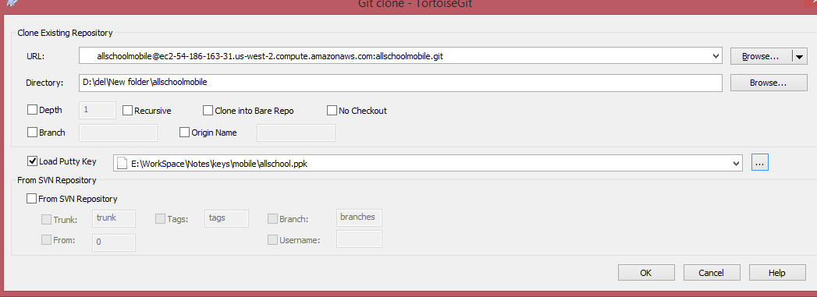

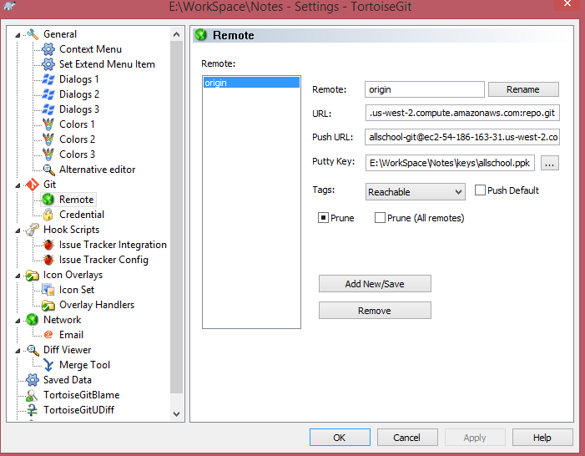

**For mac :**

**Mac will need pem file. File permission should be 600.**

**I had issues if I tried to clone first time on mac. If I first ssh into server using command**

**ssh -i "/Volumes/Xtra/workspace/BharatRailsTomcat/keys/allschool/web/allschool.pem"** [**allschool-git@ec2-54-186-163-31.us-west-2.compute.amazonaws.com**](mailto:allschool-git@ec2-54-186-163-31.us-west-2.compute.amazonaws.com)

**I can use git clone after that without any issue.**

**Change username and key path depending on which server you can access and path to key on your machine. You should have passphrase to use ssh.**

follow instructions :

http://stackoverflow.com/questions/19227642/include-pem-for-git-pull-push

Hostname ec2-54-186-163-31.us-west-2.compute.amazonaws.com

User allschool-git

IdentityFile path to allschool.pem

After setup try

<git clone [allschool-git@ec2-54-186-163-31.us-west-2.compute.amazonaws.com](mailto:allschool-git@ec2-54-186-163-31.us-west-2.compute.amazonaws.com):repo.git>

If you face any error , try checking <https://shirtdev.wordpress.com/2011/05/04/setting-up-a-git-repository-on-an-amazon-ec2-instance>

http://stackoverflow.com/questions/10904339/github-fatal-remote-origin-already-exists

You can also try using source tree. It is a free git management app for mac.

Cloning with source tree :

Do ssh once , and make host file first, then clone.

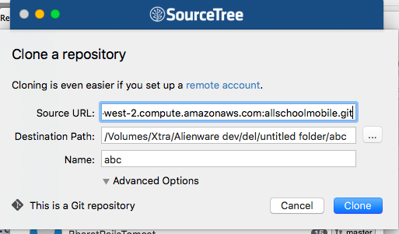

If you get url remote url error during first pull / push use this command

git remote set-url origin allschoolmobile@ec2-54-186-163-31.us-west-2.compute.amazonaws.com:allschoolmobile.git